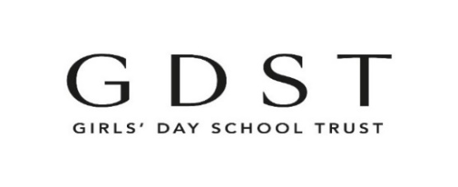

Whistleblowing Policy and Procedure

- Introduction

The purpose of this policy is to outline the GDST’s position on whistleblowing, which is the reporting or exposing of suspected wrongdoing in the workplace. The GDST is committed to conducting its business with honesty and integrity and we expect all staff to maintain high standards. However, all organisations face the risk of things going wrong from time to time, or of unknowingly harbouring illegal or unethical conduct. A culture of openness and accountability is essential in order to prevent such situations occurring or to address them when they do occur.

It is very important to the GDST that any fraud, misconduct or wrongdoing by employees is reported and properly dealt with. The GDST therefore encourages all individuals to raise any concerns that they may have about wrongdoing within the organisation. As an organisation, we recognise that raising a concern can be daunting and we are grateful to those who speak up.
This policy sets out the procedure for raising a whistleblowing concern and the responsibilities for reporting and investigating any concerns raised. The GDST is committed to treating referrals seriously, consistently and fairly, and to taking the action necessary to prevent and eliminate wrongdoing within the GDST.

This policy applies to all school and Trust Office staff and any individual classed as a ‘worker’. https://www.gov.uk/employment-status/worker Where this policy refers to staff or a staff member, it also applies to any person classed as a worker. We also encourage other stakeholders to share concerns, for example volunteers, contractors and agency staff, who should also contact the Head of Internal Audit for advice at whistleblowing@wes.gdst.net or speak to a member of their School Leadership Team.

If, after reading this policy, any member of staff is unclear about the appropriate course of action to take, please contact the GDST Head of Internal Audit for further guidance.

This policy does not form part of staff contracts of employment and GDST reserves the right to amend or withdraw it at any time.

- Background
The Public Interest Disclosure Act 1998 amended the Employment Rights Act 1996 to provide protection for workers who raise legitimate concerns about specified matters. These are called 'qualifying disclosures'. A qualifying disclosure is one made by an employee who has a reasonable belief that:
- a criminal offence
- a miscarriage of justice
- an act creating risk to health and safety
- an act causing damage to the environment
- a breach of any other legal obligation
- concealment of any of the above
is being, has been, or is likely to be, committed. This could include concerns regarding bribery, financial fraud or mismanagement, tax evasion, negligence and unauthorised disclosure of confidential information.
It is not necessary for the worker to have proof that such an act is being, has been, or is likely to be, committed – a reasonable belief is sufficient. The worker has no responsibility for investigating the matter – it is the organisation's responsibility to ensure that an investigation takes place.

Staff who make such a protected disclosure have the right not to be dismissed, or subjected to victimisation, because they have made the disclosure.

The GDST encourages employees to raise their concerns informally and in confidence with their line manager, the Head or an appropriate member of staff at Trust Office in the first instance. We know that it is never easy to report a concern, particularly one that may relate to child protection or safeguarding, fraud or corruption. We urge you to come forward with any concerns at an early stage, and before problems have a chance to become serious. The GDST's Employee Assistance Programme can also be contacted confidentially for advice if you are unsure of what to do https://gdsto365.sharepoint.com/sites/gdst-hub/Lists/Policies/DispForm.aspx?ID=46.

It is the responsibility of line managers to ensure that new staff are aware of this policy during their induction period. Managers should also encourage existing staff, at appropriate intervals, of the importance of raising concerns as they arise.

If you are not satisfied with the outcome of an informal discussion, or if for any other reason you feel it inappropriate to bring forward the issue on an informal basis, you should then raise the matter in accordance with the following procedures.

- Principles

Everyone should be aware of the importance of preventing and eliminating wrongdoing at work. Employees should be watchful for illegal or unethical conduct and report anything of that nature of which they become aware.

The GDST is committed to treating disclosures consistently and fairly. Any matter raised under this procedure will be investigated thoroughly and promptly. We will also make every effort possible to ensure confidentially (unless, for example, we are required by law or a regulator to break that confidentiality). If we wish to share details of your disclosure with others as part of our investigation, we will discuss this with you in advance. Feedback on timings and actions will be given, where possible and appropriate, so that those raising concerns understand how their disclosure has been handled and dealt with. The outcome of the investigation will be reported back to the employee who raised the issue, although there may be some restrictions due to confidentiality if the disclosure leads to further action, such as a disciplinary investigation into another member of staff. If no action is to be taken, the reason for this will be explained.

We do not encourage staff to raise concerns anonymously, but we would prefer anonymous reporting over remaining silent. Although we will investigate any concern that is reported anonymously as best we can, an anonymous report is likely to be more difficult for us to investigate and we will not be in a position to provide the individual raising the concern with any feedback.

No staff member will be victimised for raising a matter under this procedure. This applies equally if you come forward with a concern that turns out later not to have been justified. Those raising a matter will be offered support and access to advice and counselling if needed.

Victimisation of a staff member for raising a qualified disclosure is unacceptable and will be a serious disciplinary offence.

If misconduct is discovered as a result of any investigation under this procedure the GDST's disciplinary procedure will be used, in addition to any appropriate external measures.

Deliberately making a false allegation may be a disciplinary issue.

An instruction to cover up wrongdoing is itself a disciplinary offence. If told not to raise or pursue any concern, even by a person in authority such as a manager, employees should not agree to remain silent. They should report the matter to a more senior manager

4.Procedure

A flowchart is provided below to provide guidance on actions to take. Please note that this reflects the general course of action to be taken, but does not cover every eventuality. The Head of Internal Audit can provide further advice as required.

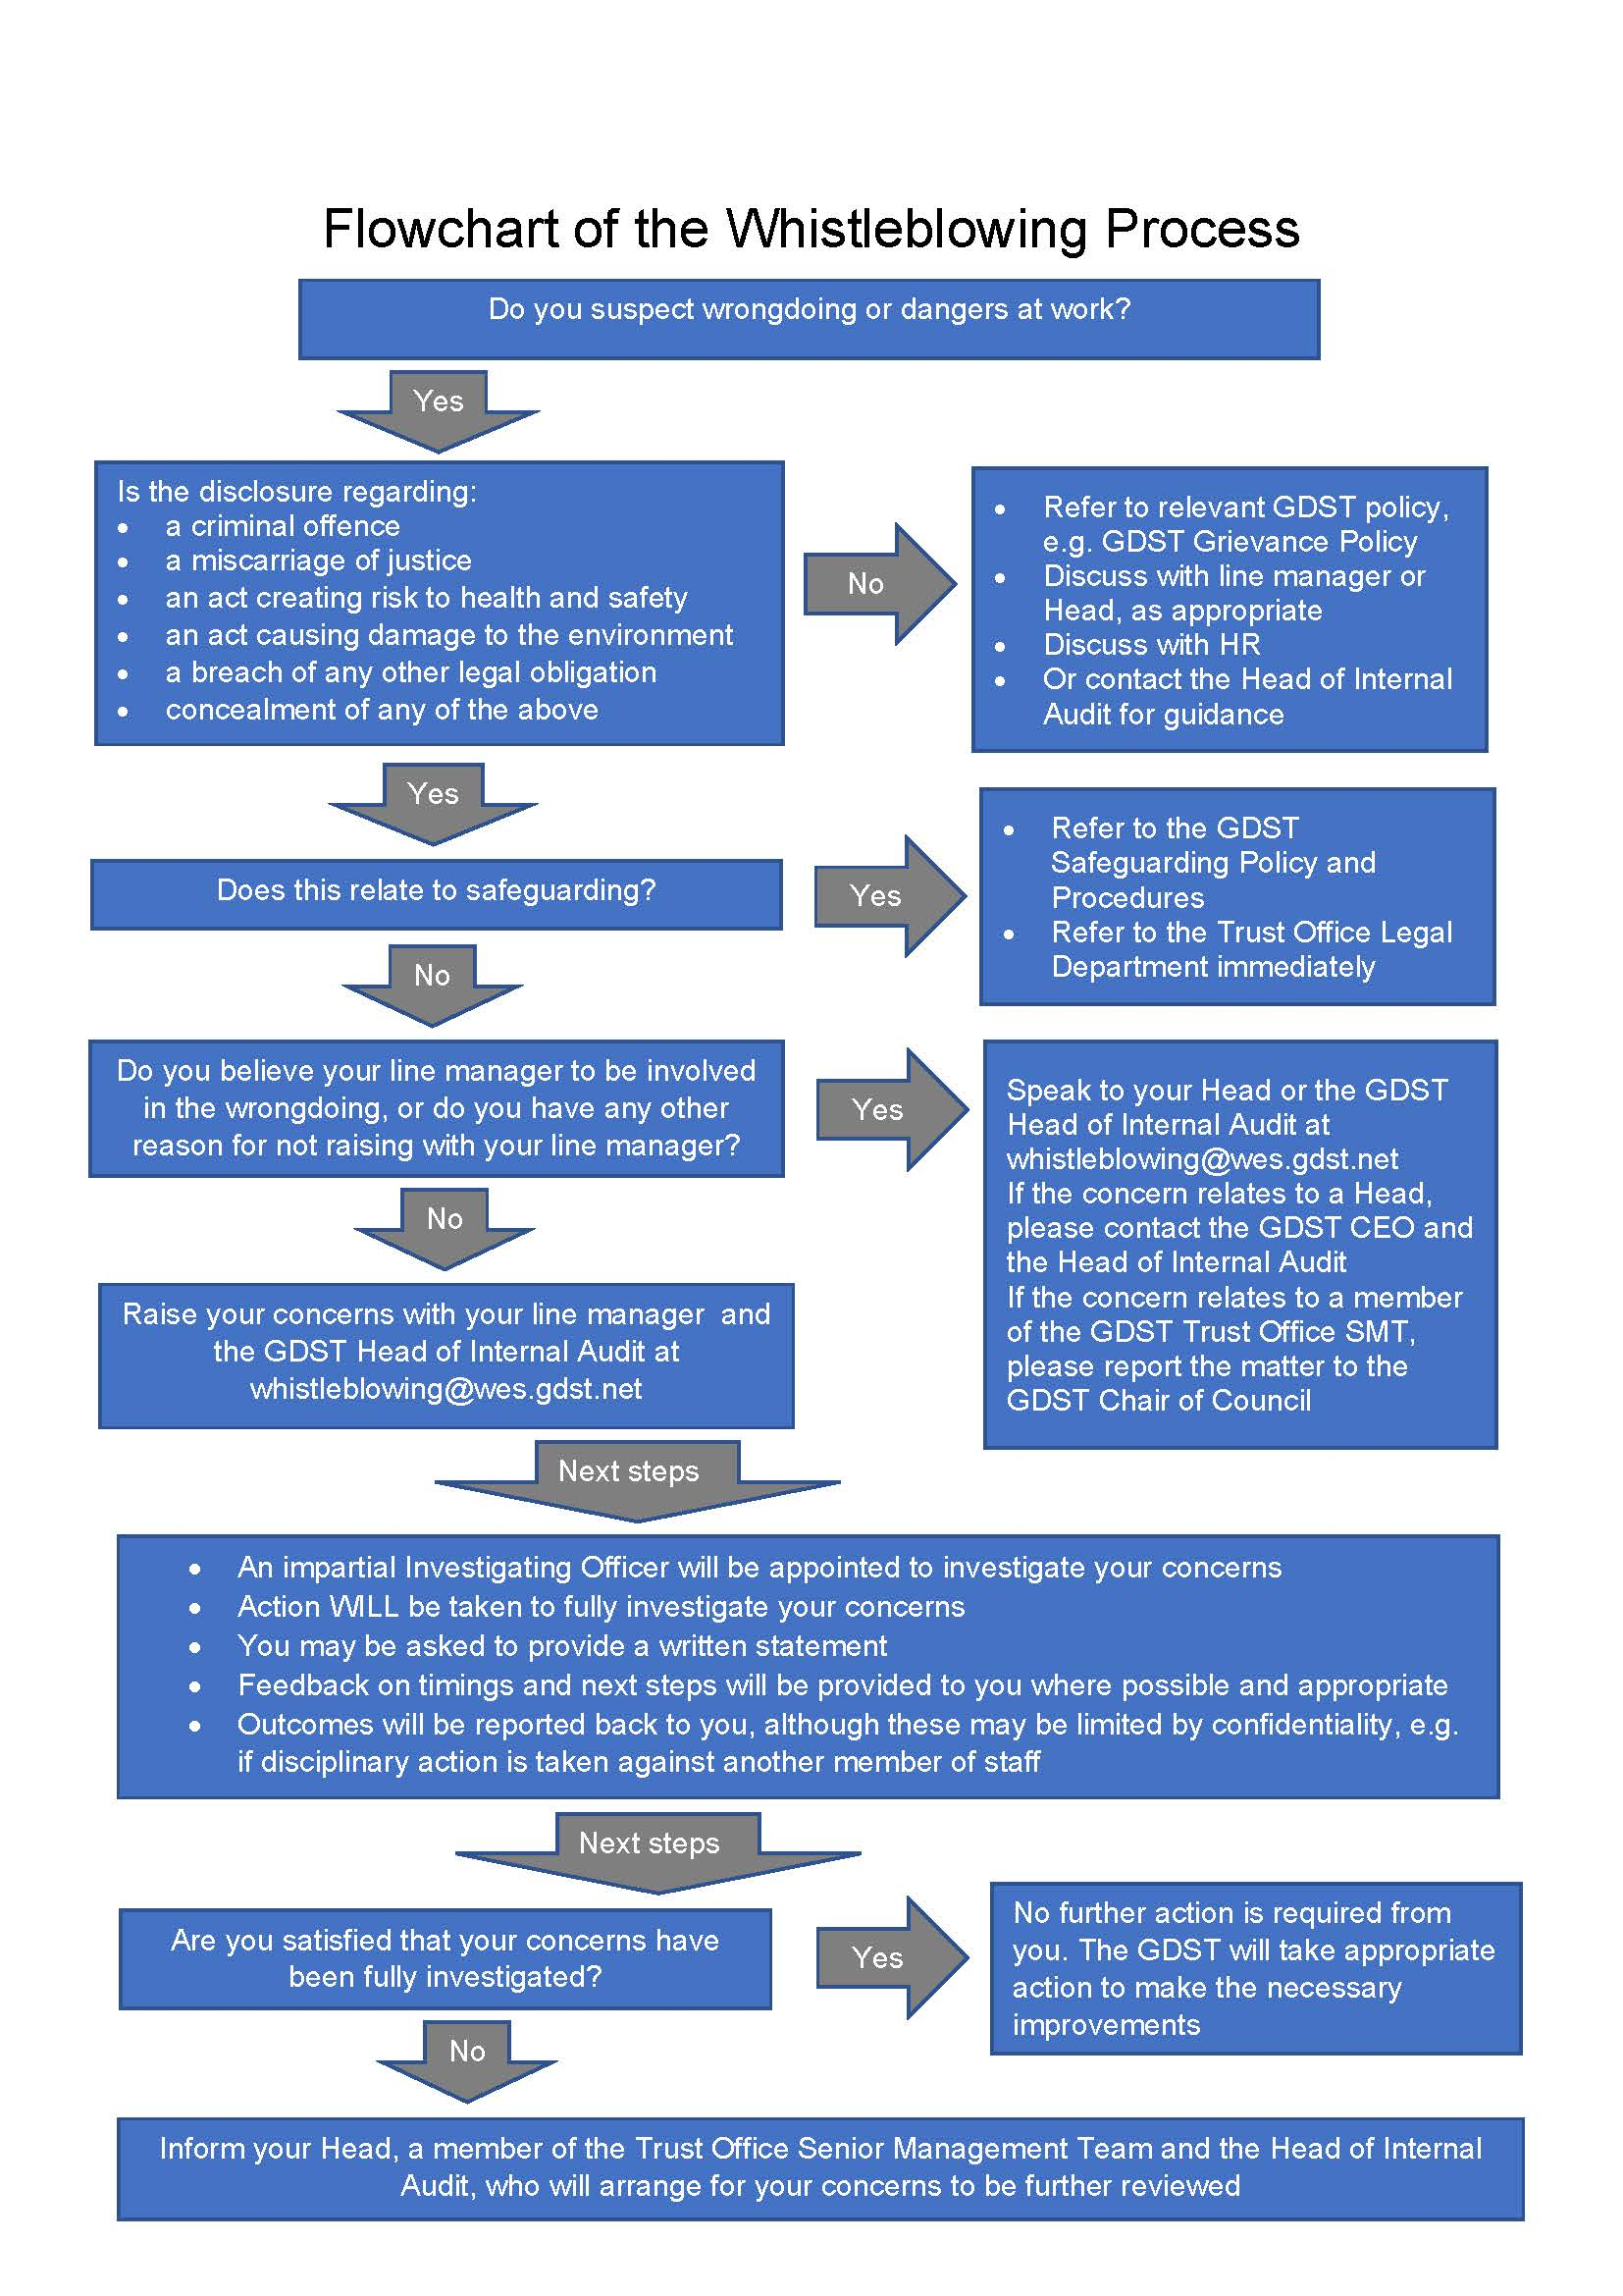

This procedure is for disclosures about matters other than a personal grievance or complaint or a breach of an employee’s own contract of employment. If you are concerned that your contract has been, or is likely to be, broken, you should use the Grievance Procedure. If in any doubt, useful information can be found at https://www.gov.uk/whistleblowing Equally, if a complaint relates to your own personal circumstances but you also have wider concerns that you think amount to a whistleblowing disclosure, you should discuss with the Head of Internal Audit, which route is the most appropriate.

In matters of safeguarding and child protection there are separate procedures for reporting concerns, which must be followed in all instances of this nature. Please refer to the GDST’s Safeguarding Policy and Procedures.
5.Stage 1

In the first instance, any concerns should be raised with your line manager and the Head of Internal Audit at Trust Office via whistleblowing@wes.gdst.net This allows Trust Office to record and maintain an overview of all disclosures. If you reasonably believe your line manager to be involved in any wrongdoing, or for any other reason do not wish to approach your line manager, then you should proceed straight to stage 2. If you prefer, you may come forward with another colleague, a friend, trade union representative or other advisor to report a concern.
The Head of Internal Audit and your line manager will decide who is the most appropriate person to carry out an impartial investigation of the matter, as the Investigating Officer. Feedback on timings or next steps will be provided to you where possible and appropriate. The investigation may involve you giving a written statement. The Investigating Officer will then report to the Head and a member of the Senior Management Team at Trust Office as appropriate, who will initiate any necessary action, including action under the GDST’s disciplinary procedure and/or reporting the matter to any appropriate government department or regulatory agency.

6.Stage 2

If you are concerned that your line manager is involved in the wrongdoing, or the Investigating Officer has failed to make a proper investigation or to report properly the outcome of the investigations, you should inform the Head of your school or a member of the Senior Management Team at Trust Office who will arrange for another manager or appropriate person to investigate or review an investigation already carried out, and make his or her own report as in stage 1 above. As above, you should also, at the same time, inform the Head of Internal Audit at Trust Office of the concern. If for any other reason you do not wish to approach your line manager you should contact the Head or a member of the Senior Management Team at Trust Office as above. Any such approach will be treated with the strictest confidence and your identity will not be disclosed without your prior consent.

7.Stage 3

If you are concerned that the Head or any other senior manager within the organisation is involved in any wrongdoing, you should inform both:

the Chief Executive Officer of the Trust, or another member of the senior management team at Trust Office
AND
the GDST’s Head of Internal Audit at Trust Office

They will arrange for an investigation to be undertaken by an appropriate person or agency in accordance with the principles outlined above.
8.Stage 4

If on conclusion of stages 1, 2 and 3, you reasonably believe that the appropriate action has not been taken, you should report the matter to the Chair of Council This is also the process you should follow if your concerns relate to the GDST Trust Office Senior Management Team.

The legislation sets out a number of bodies to which qualifying disclosures may be made. https://www.gov.uk/government/publications/blowing-the-whistle-list-of-prescribed-people-and-bodies--2/whistleblowing-list-of-prescribed-people-and-bodies

These include:
- the Charity Commission – 03000 669 197 or www.charitycommission.gov.uk or whistleblowing@charitycommission.gsi.gov.uk
- the Children’s Commissioner - 020 7783 833 or www.childrenscommissioner.gov.uk
- NSPCC whistleblowing helpline – 0800 028 0285 or help@nspcc.org.uk
- HM Revenue & Customs (Tax Office) – 0800 788 887 or http://www.hmrc.gov.uk
- the Financial Conduct Authority – 020 7066 1000 or http://www.fca.org.uk/
- the Health and Safety Executive – 0300 003 1647 or http://www.hse.gov.uk
- the Environment Agency – 03708 506 506 or www.environment-agency.gov.uk
- In addition, the independent Whistleblowing charity, Protect operates a hotline that individuals can contact if they require external, confidential advice. They can be contacted at 020 3117 2520 or via www.protect-advice.org.uk.
This procedure may be amended from time to time by the GDST, in order to reflect changes in statutory requirements or organisational changes within the GDST. Substantive changes will only be made following consultation with appropriate employee representatives.

Document control and relevant information
DOCUMENT TITLE: | WHISTLEBLOWING POLICY AND PROCEDURE
VERSION NUMBER: | 5
EFFECTIVE DATE: | 03/01/2023
DATE OF PREVIOUS REVISIONS: | August 2016; April 2015, December 2018
DATE OF FIRST ISSUE: | 2005
DISTRIBUTION / AUDIENCE: | All staff
POLICY LEAD(S)/AUTHOR(S): | Kate Hailstone, Head of Internal Audit
LEAD DEPARTMENT: | Legal and Risk Assurance
INPUT FROM OTHER DEPARTMENTS: | Human Resources, Education, Governance
CONSULTEES: | Heads, National Education Union
POLICY APPROVAL: | Audit Committee, Exec Board, JCG
POLICY REVIEW ARRANGEMENTS: | Biennial
OTHER RELEVANT INFORMATION | N/A

