BRIGHTON GIRLS policy
SELF-HARM

Document Control
Document Owner & Contact Person : |  | Valid as of:
Wendy Fox  Deputy Head Pastoral |  | January 2021
School: | Version: | Last Review:
Brighton Girls | 03 | June 2020

TABLE OF CONTENTS

1. PURPOSE & APPLICABILITY 2
2. LIST OF ABBREVIATIONS & MEANINGS 2
3. GENERAL REQUIREMENTS 2
3.1. INTRODUCTION 2
3.2. CREATING A CULTURE OF SAFEGUARDING 3
3.3. AIMS AND OBJECTIVES 3
3.4. IDENTIFYING SELF-HARM 4
3.4.1. WHAT IS SELF- HARM? 4
3.4.2. POSSIBLE SIGNS OF SELF- HARM 4
3.5. DESIGNATED TEACHER 4
3.6. MANAGING SELF- HARM. 5
3.7. RESPONDING TO DISCLOSURES OF SELF-HARM 6
3.7.1. IMMEDIATE RESPONSE 6
3.7.2. THE MEMBER OF STAFF OR VOLUNTEER SHOULD NOT: 7
3.8. RECORDING INFORMATION 8
3.9. REPORTING TO THE DESIGNATED TEACHER 8
3.10. KEY CONTACTS 8
3.11. LOCAL CHILD AND ADOLESCENT MENTAL HEALTH SERVICES: 9
4. APPENDIX 10
4.1. PRACTICAL GUIDELINES FLOWCHART 10
4.2. RISK ASSESSMENT KEY ISSUES PROMPT FORM 11
5. DOCUMENT HISTORY 12

PURPOSE & APPLICABILITY
This policy provides guidelines for the arrangements that have been made by Brighton Girls related to self-harm.
This policy is applicable to Brighton Girls

List of Abbreviations & Meanings
BG Brighton Girls
CAMHS Child and Adolescent Mental Health Services
EYFS Early Years Foundation Stage
GDST Girls Day School Trust
INSET Training during term time for teachers in British schools
LSCB Local Safeguarding Children Board
SLT Senior Leadership Team

May / Should Advisory
Shall / Must Mandatory

general requirements

Introduction
Brighton Girls is committed to safeguarding and promoting the welfare of children and believes that all pupils, regardless of age, special needs or disability, racial/cultural heritage, religious belief or sexual orientation have the right to be protected from all types of harm and abuse. This Self Harm Policy forms a fundamental part of our approach to providing excellent pastoral care to all pupils, including young people who may be over the age of 18 years and links with our Safeguarding Policy and our Anti-bullying Policy.
- This Policy is used in accordance with locally agreed inter-agency procedures, and specifically in accordance with Brighton and Hove’s Safeguarding Children Partners (BHSCP) guidance.
- This Policy is addressed to all members of staff and volunteers at the School. Adherence to this Policy is mandatory for all staff and volunteers and its use is not subject to discretion. This Policy applies whenever staff or volunteers are working with pupils including where this is away from the School, for example at another institution, school visits and trips, as well as sporting and cultural activities.
- This Policy is available to all parents, staff and volunteers on the School’s website. A paper copy of this Policy is also available to parents upon request to the School office.
- Pupils are made aware of this Policy through their programme of PSHE (Well-Being Lessons) and other means of sharing information appropriate to their age and understanding.

Creating a Culture of Safeguarding
- The School takes its responsibilities very seriously. As well as ensuring the School’s policies and procedures support its safeguarding responsibilities, the School will work with pupils, their families, Social Services Departments and other relevant agencies to ensure the risk of harm to children is minimised.
- The School is committed to working in partnership with parents, CAMHS and diverse communities, to continuously develop and improve the safeguarding culture within our School.
- Having these safeguards in place not only protects and promotes the welfare of children but also it enhances the confidence of our staff, volunteers, parents/carers and the general public.
- The School encourages the pupils in its care to raise any concerns that they might have and ensure that these are taken seriously. The School also encourages pupils to contribute their own ideas, according to their age and understanding, about how their safety and welfare could be further improved.

Aims and Objectives
The aim of this policy is twofold:
- to try and prevent self- harm as far as possible and
- to help staff, pupils and parents to deal with self- harm when it occurs
This ethos means that:
- We use Well-Being lessons and activities, codes of conduct, assemblies, projects, stories and literature, current affairs, historical events, form time and other curriculum approaches to discuss and tackle self- esteem and the issues surrounding self-harm.
- We train staff to understand why people self- harm, to recognise the potential signs of self- harm and how to deal with it when it occurs and have systems in place for supporting girls who are self- harming. Training forms part of Staff Induction and is also part of the staff INSET programme

Identifying Self-harm

What is self- harm?
When some people feel sad, desperate, angry or confused, they can hurt themselves. This is called ‘self- harm’.
People can harm themselves in a number of ways and for different reasons.
People who harm themselves on more than one occasion may do so for a different reason each time. They may also harm themselves and not tell anyone about it.
Self- harm is closely linked with low self-esteem and poor self-image

Possible signs of self- harm
Changes in behaviour that may indicate that a pupil is self- harming include:
  - Cutting
  - Scalding
  - Hair pulling
  - Breaking bones
  - Banging
  - Ingesting
  - Restrictive eating
  - Displaying repressed body language and poor eye contact
Although there may be other causes for some of the above symptoms, a repetition of, or a combination of these possible signs of self- harm should be investigated by parents and teachers.

Designated Teacher
The School has appointed [a Designated Teacher/Designated Teachers] and a person to contact in their absence. The Designated Teacher[s] [is a/are] member[s] of the School’s Senior Leadership Team with the necessary status and authority to take responsibility for self-harm matters. The Designated Teacher[s] at the School [is/are:
  - Wendy Fox in the Senior School and in case of her absence, Nicola Latter or Nicki Scotcher
  - Charlie Parker in the Prep School and in case of her absence, Poppy Pointon or Helen Hausdoerfer.
  - The Designated Teacher with lead responsibility for child protection within Early Years Foundation Setting is Charlie Parker.

The Designated Teacher[s] will:
  - Be responsible for ensuring that all self-harm concerns are investigated and managed in accordance with the safeguarding guidance and regulations set out at paragraphs 1.1.2 of the Safeguarding Policy.
  - Liaise with Sharon Honeycombe over cases of self-harm.
  - Encourage the self-harmer to tell their parents or carers in the first instance. If this does not happen, Sharon Honeycombe will contact parents unless there are child protection issues.
  - Ensure that he/she/they is/are aware of the latest national and local guidance and requirements and will keep the Head, staff and volunteers informed as appropriate
  - Act as a source of advice and support within the School and co-ordinate action regarding cases of self-harm.

Managing self- harm.
Brighton and Hove High School is pro-active and provides the following preventative measures:
  - The Well-Being programme is structured to give pupils an awareness of their social and moral responsibilities as they progress through the school. The programme is structured to enforce the message about community involvement and taking care of each other and focus is given on self- esteem.
  - Staff are always on duty at times when pupils are not in class. They are trained to be alert to behaviour linked with self- harm.
  - A strong and experienced pastoral team of Sharon Honeycombe (School Nurse), Natasha Edwards (School Counsellor), Valeria Zinola (SENDCO), Nicola Latter (Deputy Designated Safeguarding Lead ), Nicki Scotcher (Deputy Designated Safeguarding Lead ), Nicci Latter (Head of Year 7), Nicki Scotcher (Head of Middle School), Angela Watson (Head of Year 10), Caroline Hart (Head of Year 11), Olivia Pianet ( Head of Sixth Form) and Wendy Fox (Deputy Head Pastoral and Designated Safeguarding Lead and E Safety Officer) are trained in handling any incidents as an immediate priority, and are alert to possible signs of self- harm (Senior School).
A strong and experienced team of teaching staff including Charlotte Parker (Deputy Head, Head of Pastoral Care, Designated Safeguarding Lead and E Safety Officer), Poppy Pointon (Deputy Designated Safeguarding Lead), Helen Hausdoerfer (Deputy Designated Safeguarding Lead) and class teachers support the Prep Head and are trained in handling any incidents as an immediate priority, and are alert to possible signs of self- harm (Prep School).
  - The school pastoral team give support and guidance to other staff on handling and reporting incidents, and on the follow-up work with pupils who are self- harming.
  - In the Senior School- A trained School Nurse (Sharon Honeycombe) and a School Counsellor (Natasha Edwards) are an important part of the pastoral support service, providing up to date advice on self- harm and specialist skills of assessment.
  - Advice is displayed in the Nurse’s Room, on the Peer Support notice board and in the girls’ school planners (Senior School) / by the Medical Room, in the cloakrooms and the Playground (Prep School) on where pupils can seek help, including details of confidential help lines and web sites connecting to external specialists, such as Childline, Kidscape, Get Connected, Samaritans.
  - All pupils have access to a telephone helpline, enabling them to call for support in private.
  - In the Prep school staff are well trained in alerting both Charlotte Parker and Poppy Pointon/ Helen Hausdoerfer who work closely with all staff and, where necessary, outside agencies. Pupils are also able to ask all members of staff for support and can ask for a specific time with Charlotte Parker if they would like to. These requests are always taken seriously.

Responding to disclosures of Self-Harm
Staff and volunteers should make themselves available to listen and demonstrate to the pupil that what they are saying is being taken seriously and without criticism and should respond in a supportive, calm manner and avoid asking detailed questions. The role of the staff or volunteer is to listen, record and report; not to investigate.

Immediate Response
If a disclosure of self-harm is made, the member of staff or volunteer should:
  - Allow the pace of the conversation to be dictated by the pupil
  - Ask open questions which encourage the pupil to talk such as “can you tell me what happened?”
  - Accept what the pupil says and do not ask for further detail
  - Acknowledge how hard it was for them to tell you and show by voice tone and/or facial expression that you are taking their concerns seriously
  - Note carefully any clearly visible external signs of possible injury
  - Re assure the pupil that they have done the right thing, that it is not their fault, and explain whom you will have to tell (the designated teacher) and why.
  - Use the practical guidelines flowchart to help structure a conversation with a student who is disclosing self-harm (Appendix 4.1 ).

The member of staff or volunteer should not:
  - Burden the pupil with guilt by asking questions such as “why didn’t you tell me before?”
  - Interrogate or pressure the pupil to provide information
  - Ask any potentially leading questions such as those that start with the words, how, what, when, where and why
  - Undress the child or examine clothed parts of the child’s body in an attempt to determine the nature of any such injuries
  - Promise confidentiality
  - Make promises that they cannot keep such as “i’ll stay with you all the time” or “it will be alright now”
  - Put words in the child's mouth (i.e. Finish their sentences)
  - Jump to conclusions or speculate about what happened or might have happened, or make accusations
  - Show an overly emotional reaction, such as expressing disgust, shock or disbelief
  - If a pupil confides in a member of staff or volunteer and requests that the information is kept secret, staff/volunteers must not make promises about confidentiality. Staff must tell the pupil sensitively that they have a responsibility to tell the named designated teacher so that the child can be helped to stay safe and feel better.
  - In every case, the staff/volunteer should consider whether the pupil is able to provide consent for the information to be shared and if so, seek to obtain that consent in accordance with the GDST safeguarding procedures relating to information sharing and consent. If the pupil does not consent, the staff/volunteer should explain that they need to share the information with the designated teacher and reassure them that the information will only be disclosed to other people who need to know. The member of staff/volunteer should refer to the GDST safeguarding procedures for further information and guidance.
  - The school recognises that a child who is self-harming may feel helpless and humiliated, may blame themselves, and find it difficult to develop and maintain a sense of self- worth.
  - The school will provide continuing support to a pupil who has disclosed self-harming through promoting a caring and safe environment within the school and encouraging self-esteem and self-assertiveness through the curriculum and through relationships. In doing so, the schools will act in accordance with guidance from the relevant authorities to ensure that, for example, legal proceedings are not compromised.

Recording Information
Staff/volunteers should:
  - Make brief notes at the time or immediately afterwards, which record the date, time, place and context of the disclosure or concern, and what has actually been said (wherever possible using the child's exact words, even if they seem childish, rude or inappropriate), not assumption or interpretation. Notes must be signed and dated
  - Clearly distinguish between fact, observation, allegation and opinion
  - Record any observed injuries and bruises
  - Note the non-verbal behaviour and the key words in the language used by the pupil (do not translate into “proper terms”)
  - Complete a safeguarding concern form, attach any original notes and pass them to the designated teacher
  - Use the risk assessment key issues prompt form to help identify the severity of the risk (appendix 4.2).

Reporting to the Designated Teacher
  - Any concerns about pupils must be discussed with the Designated Teacher (or in their absence the Deputy Designated Teacher) as soon as possible and at latest by the end of the school day.

Key Contacts
- Rosie McColl Head
Tel: 01273 280280 (Ext 17220) r.mccoll@brightongirls.gdst.net

- Wendy Fox Designated Teacher (Senior School)
Tel: 01273 280280 (Ext 17199) w.fox@brightongirls.gdst.net

- Nicki Scotcher Deputy Designated Teacher (Senior School)
Tel: 01273 280280 (Ext 17215) n.scotcher@brightongirls.gdst.net

- Nicola Latter(Jan 2019) Deputy Designated Teacher (Senior School)
Tel: 01273 280280 (Ext 17215) n.latter@brightongirls. gdst.net

- Laura Comerford Designated Teacher and EYFS (Prep School)
Tel: 01273 280200 l.comerford@brightongirls. gdst.net

- Poppy Pointon Deputy Designated Teacher (Prep School)
Tel: 01273 280200 p.pointon@brightongirls.gdst.net
- Helen Hausdoerfer Deputy Designated Teacher (Prep School)
Tel: 01273 280200 h.hausdoerfer@brightongirls.gdst.net

- Sharon Honeycombe School Nurse
Tel: 01273 280280 (Ext 17157) s.honeycombe@brightongirls.gdst.net

- Natasha Edwards School Counsellor
Tel: 01273 280280 n.edwards@brightongirls.gdst.net

Local Child and Adolescent Mental Health Services:
CAMHS
The Aldrington Centre
35 New Church Road
Hove
BN3 4AG
Telephone (01273) 718680
Fax (01273) 738407

Appendix

Practical guidelines flowchart
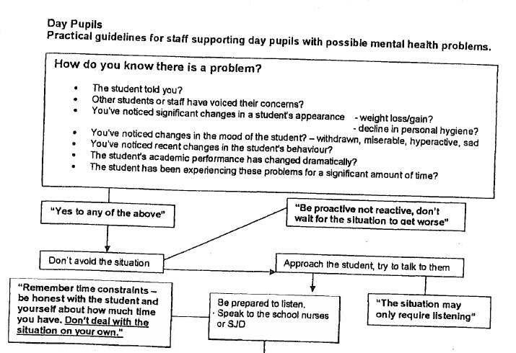
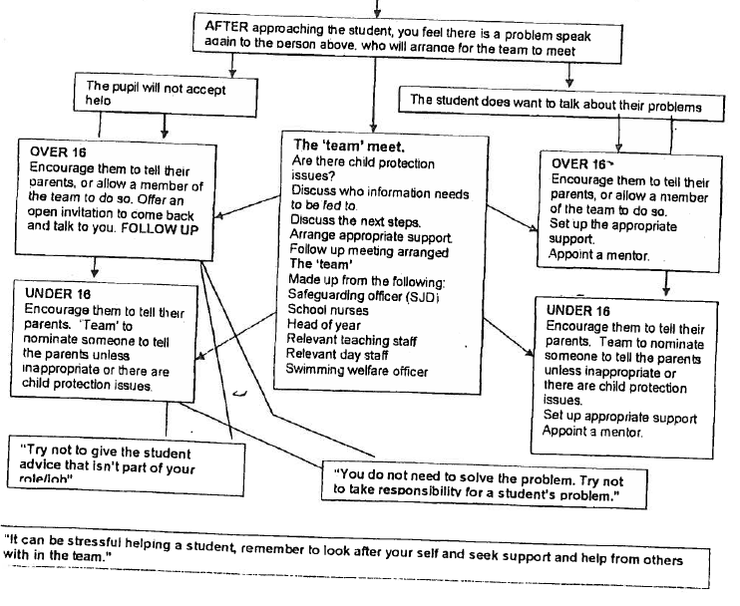

Risk Assessment Key Issues Prompt Form

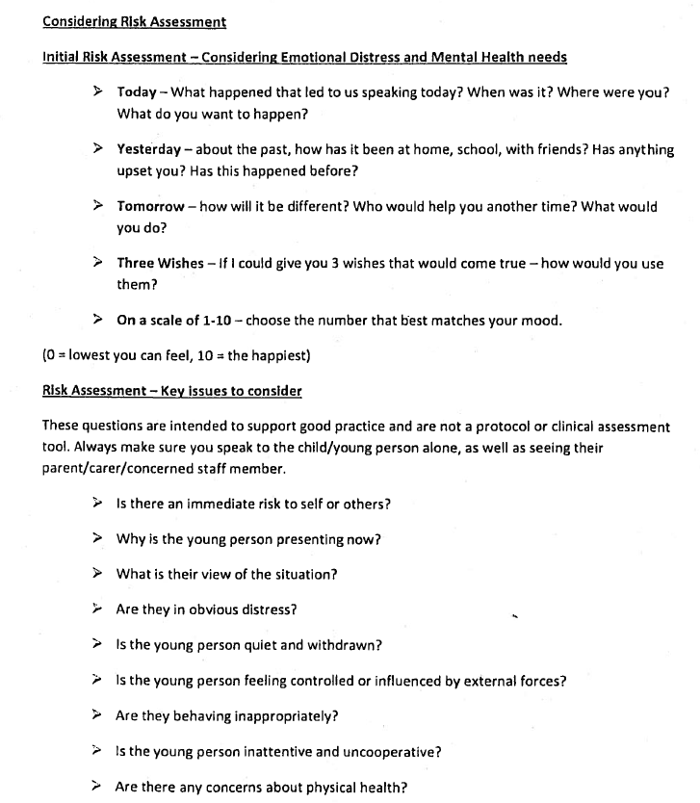

Document History

Document Title | Version | Date of Issue | Change | Updated by | Status
Brighton and Hove High School Self-Harm Policy | Initial | September  2016 | NIL | Wendy Fox | Expired
Brighton and Hove High School Self-Harm Policy | 01 | September  2017 | Full Review | Wendy Fox | Expired
Brighton and Hove High School Self-Harm Policy | 02 | October 2017 | New Policy Template | Paul Fairhurst | Expired
Brighton Girls Self-Harm Policy | 03 | September 2019 | Review | Wendy Fox | Live

END OF DOCUMENT

