BRIGHTON GIRLS policy
ENGLISH AS AN ADDITIONAL LANGUAGE (EAL)

Document Control
Document Owner & Contact Person : |  | Valid as of:
Kate Ashdown  Deputy Head |  | September 2019
School: | Version: | Last Review:
BHHS Prep, High, Sixth | 02 | September 2019
TABLE OF CONTENTS

1. PURPOSE & APPLICABILITY 2
2. LIST OF ABBREVIATIONS & MEANINGS 2
3. GENERAL 2
3.1. SCHOOL CONTEXT & SUMMARY 2
3.2. DEFINITION 3
3.3. AIMS OF THE POLICY 3
3.4. THE SCHOOL’S EAL OBJECTIVES 3
3.5. ROLES AND RESPONSIBILITIES FOR MANAGEMENT OF PROVISION 4
3.6. PROVISION – SENIOR SCHOOL 4
3.6.1. SCHEME OF WORK (SOW) 4
3.6.2. CLASSROOM PROVISION: 4
3.6.3. ADDITIONAL SPECIFIC PROVISION: 5
3.6.4. PASTORAL PROVISION: 5
3.6.5. PROMOTION OF BILINGUALISM: 5
3.7. PROVISION - EYFS 5
3.8. ADMISSIONS & ASSESSMENT 5
3.9. IDENTIFYING PUPILS WITH EAL 6
3.10. IDENTIFYING GIFTED AND TALENTED PUPILS WITH EAL 6
3.11. IDENTIFYING SEN IN EAL PUPILS 6
3.12. ADDITIONAL SUPPORT FOR EAL STUDENTS 6
3.13. RECORDING, MONITORING AND REPORTING 6
3.14. STAFF SUPPORT & TRAINING 7
3.15. SUCCESS CRITERIA 7
3.16. POLICY CROSS REFERENCE 8
4. APPENDIX 9

PURPOSE & APPLICABILITY
This policy provides guidelines for the arrangements that have been made by BHHS related to students with English as an additional language.

This policy applies to Brighton Girls Senior, Prep, High & Sixth Form School.

List of Abbreviations & Meanings
BGS Brighton Girls’ School
EAL English as an Additional Language
GDST Girls’ Day School Trust
SENDCo Special Education Needs & Disabilities Coordinator
SOW Scheme of Work
TEFL Teaching English as a Foreign Language

May / Should Advisory
Shall / Must Mandatory

general

School Context & Summary
Brighton Girls’ School is an independent, selective school. A competitive entrance exam and high academic standards applied across all subjects mean that the school does not cater for EAL beginners.

All students who speak English as an additional language at BGS are advanced learners of EAL. EAL learners constitute less than 3% of the school population. We recognise that a significant number of our pupils speak more than one language at home, although they do not consider themselves EAL learners. Bilingualism and multilingualism are actively promoted and a specific provision exists to cater for advanced speakers of Latin, French and Spanish.

When a student joins us that has English as a second language, the EAL Co-ordinator will liaise with the student and the family to decide whether a bilingual dictionary is advisable in certain subjects. This will be done on a case by case basis.

Upon entry to the Senior School, students needing EAL support will firstly have their level of English assessed and then they are supported through the use a range of materials at an appropriate level to support and develop their English.
Subject teachers are also involved as they help to determine what specific help the students may need week by week. Additionally, the EAL Co-ordinator will provide them with an opportunity to ask for support and advice about school life in general, when they are unsure of procedures, rules, etiquette etc.

Definition
We define as a student with English as an Additional language (EAL), one, who does not have English as a mother tongue. We would include students who are bi-lingual as those, who have English as a mother tongue as well as another language.

Aims of the Policy
The aims of this EAL policy are:
- To enable all pupils to participate in the full range of school life and activities, and to succeed to their individual potential;
- To create a positive learning environment;
- To reflect through the whole-school ethos the value placed on diversity and the respect accorded to all individuals;
- To support EAL needs as a collective, whole-school responsibility, believing that all teachers are teachers of pupils with individual needs.

The School’s EAL Objectives
- To ensure all EAL pupils are identified and procedures followed to ensure their needs are met and they achieve their potential;
- To ensure EAL pupils are integrated as fully as possible into the life of the school and offered full access to a broad, balanced and relevant education, including an appropriate curriculum;
- To ensure all EAL pupils are actively encouraged to participate in extracurricular activities;
- To ensure parents/guardians feel encouraged to play a role in EAL pupils’ education;
- To ensure appropriate resources are available and are used in the school;
- To ensure EAL pupils are enabled to achieve their potential both in the classroom and through additional EAL support where appropriate;
- To ensure the school’s overall ethos helps pupils feel valued members of the school community, thrive in a culture which may be foreign to them, and appreciate their own cultural uniqueness;

Roles and Responsibilities for Management of Provision
EAL assessment and provision is co-ordinated, in conjunction with the Head and SLT, by the SENDCo Valeria Zinola, who acts as the school’s EAL Co-ordinator.
- She ensures that pupils are identified, assessed, monitored.
- S/he keeps an up-to-date EAL register, and ensures that staff are informed of pupils’ needs and progress.
- S/he provides school staff with guidance and support relating to effective teaching approaches and materials.
- S/he advises EAL pupils on first language examinations.
- S/he liaises with parents/guardians to involve them in decision-making.

Provision – Senior School
There is no specific provision for girls with English as an Additional Language beyond that described above and below. Where needs are identified that exceed our ability to provide, parents will be given advice on possible sources of help, which they would have to pay for outside school.

Scheme of Work (SOW)
The scheme of work is a guideline developed and used by the EAL Co-ordinator that defines the structure and content of the EAL provision. It maps out how resources (e.g. books, equipment, time) and class activities (e.g. teacher-talk, group work, discussions) and assessment strategies (e.g. tests, quizzes, Q&A) will be used to ensure that the learning aims and objectives are met successfully.
The scheme of work is usually an interpretation of the needs and requirements of the individual students as the EAL Co-ordinator works with small numbers of EAL students and can be used as a guide to monitor progress against the original plan. The scheme of work covers common topic areas, as well as students’, choices of theme and includes proposed times and dates.

Classroom provision:
- Strategies for differentiation (staff);
- Teaching approaches which promote language development;
- Provision of bilingual dictionaries and other resources;
- Departmental support – subject specific vocabulary lists provided by EAL Co-ordinator.

Additional specific provision:
- For the first two years, EAL Co-ordinator provides one hour a week EAL support, instruction and mentoring for all EAL students.
- When and how students receive specialist EAL support within your current curriculum;
- External examinations in first language;
- Links with other schools/exam centres;
- Access arrangements.

Pastoral provision:
- Integration of EAL pupils within school - buddies (older/same language/boarding; lesson buddies);
- Contact with parents/guardians.

Promotion of bilingualism:
- Use of display;
- School assemblies, calendar events etc.
- Multicultural issues in schemes of work.

Provision - EYFS
In the EYFS in our Prep School we encourage children to develop language (home and English) through play and other meaningful learning opportunities. Children are surrounded in a rich language environment where English is modelled by both adults and their peers which supports the development of a good standard in English. Children are given the confidence to communicate using their developing and newly acquired language skills whilst also valuing communication in their home language. As part of our curriculum we invite families into school to share celebrations from their own cultures or home countries which can lead to the sharing of other languages.

Admissions & Assessment
For the purpose of planning appropriate provision and communication between staff and parents, EAL students’ competence in English is assessed before entry to the school. The entrance test comprises of three short papers: Verbal Reasoning, Mathematics and English, and are designed to test potential rather than knowledge. BHHS will not penalise applicants who have not had specialist teaching in these areas and does not recommend additional tutoring in preparation. It is unlikely that a student with EAL would pass the entry requirements; the possible exception to this would be a student (e.g. Chinese) entering our Sixth Form with excellent qualifications, but whose access to the curriculum would be restricted owing to a poorer command English than her peers.

Identifying pupils with EAL
Identification of EAL students would occur during the entrance test and/or interview and the additional needs discussed at that point. Occasionally, the identification could occur once the student has begun, through a particular teacher or through the PIPS or MIDYIS tests. In this case, the student would be referred to the EAL Co-ordinator, who would seek an interview with parents and discuss the most appropriate strategies.

Identifying gifted and talented pupils with EAL
Staff are alert to actual or potential high ability in EAL pupils, and they are identified and supported appropriately.

Identifying SEN in EAL pupils
When EAL pupils do not make anticipated progress this may indicate learning difficulties. Before identifying SEN the following related factors are investigated:
- possible sensory problems;
- social, emotional or behavioural needs;
- the supportiveness of the language learning environment.

Additional Support for EAL students
In the Sixth Form, Students with EAL would partake in English lessons with slightly younger students preparing for GCSE level assessments. This would occur during sixth from free periods. In severe cases, we would arrange for additional tuition in English to take place outside the classroom. This would be at the Schools’ expense for girls coming from overseas. Any student who passed the entrance test, but who did need some additional help would normally have this delivered through differentiation in lessons (English in particular).
If additional private tuition were deemed to be helpful, then this would be at parental expense and would normally be negotiated during an entrance interview.
For younger students, in particular EYFS, the classes are small enough to allow the teacher to differentiate and to offer additional support on a one-to-one basis. The use of the teaching assistant would also enable this to occur.

Recording, Monitoring and Reporting
Students are assessed for their level of English on joining the school. Having assessed their level of English using: Straightforward Quick Placement & Diagnostic test Second edition © Macmillan Publishers Limited 2012, the EAL Co-ordinator uses a range of materials at an appropriate level to support and develop their English. All subject teachers are contacted to ascertain what specific help students need week by week and teachers are given strategies for support for EAL in the classroom.
Additionally, EAL students are provided weekly with an opportunity to ask for support and advice about school life in general, when they are not clear on procedures, rules, etiquette etc.

Routine school monitoring is applied to EAL students. This includes the use of MiDYIS, CEM data, as well as using a range of evidence that is collected through assessment and monitoring or student’s work and teacher referrals. Additionally, the EAL Co-ordinator and staff can raise concerns at Pastoral team meeting and through emails and informal discussions.

A student resource file is maintained by the EAL Co-ordinator on the school subject drive and can be used by students to access EAL related information.
A teacher file is also maintained by the EAL Co-ordinator to ensure teachers have access to resources useful for EAL students during lessons – click here

A confidential staff file containing details of EAL student support is maintained within the staff drive, restricted access for only the School Head, Assistant Head & SENDCo / EAL Co-ordinator.

Staff Support & Training
The SENDCo has completed a post-graduate diploma in TEFL to support her in the role of EAL Co-ordinator.

As well as regular strategy liaison and advice from the EAL Co-ordinator, teachers have access to the SOW and an EAL Checklist via the SEND page of FireFly (school communication platform)- click here

The EAL checklist provides guidance to teachers to ensure they have created a positive learning environment specific for EAL pupils. A copy of the EAL Checklist is available via the appendix of this document – click here to be redirected to the PDF version via FireFly.

Success criteria
The effectiveness of this EAL policy is reviewed through monitoring and evaluation of various aspects of the school’s EAL provision.

Evaluation tools will include:
- EAL pupils’ levels of attainment in formal school assessments/external tests;
- Pupils’ levels of attainment in EAL assessment over time/progress demonstrated by work scrutiny;
- Progress and outcomes of target setting over time;
- Pupil retention through Sixth Form application;
- Pupils’ reports;
- Informal assessment by EAL Coordinator /teaching and pastoral staff, e.g. of participation in class, integration into school life etc.
- Informal feedback from teacher which will help guide the EAL coordinator for target setting.

Policy Cross Reference
This policy should be read in conjunction with:
- GDST Equal Opportunities Policy;
- Anti-bullying policy.

Appendix
4.1 EAL Checklist: (example only)

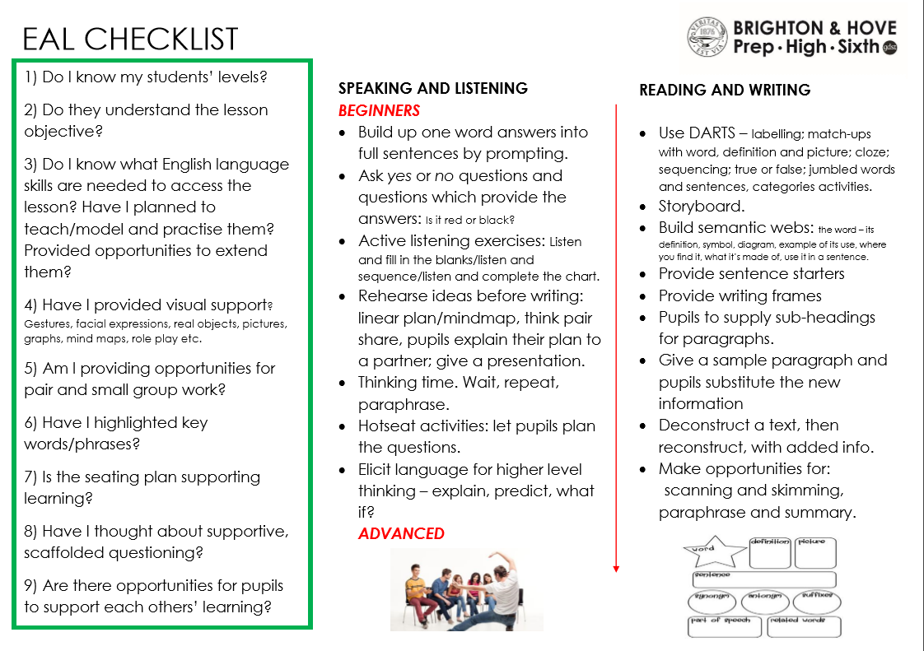

Document History

Document Title | Version | Date of Issue | Change | Updated by | Status
BHHS EAL policy | Initial | March 2018 | Initial policy developement | Valeria Zinola  Paul Fairhurst | Expired
Brighton Girls EAL policy | 02 | September 2019 | Review & change of school name | Kate Ashdown | Live

END OF DOCUMENT

